Howdy ya’ll,
The Arlington Sportsman’s Club (ASC) in Mansfield Texas hosted the 17th Annual 2021 Republic of Texas Field Target Grand Prix this past weekend, October 22-24. There were 13 competitors in Pistol and 34 competitors in Rifle, who came from six nearby and far-away states (Florida, Louisiana, Massachusetts, Minnesota, oklahoma and TEXAS). Some of the competitors were returning home from the Extreme Benchrest match in Arizona and the AAFTA Nationals in California and decided to stop in for the weekend and shoot with us. That is dedication! We also had the pleasure of shooting with Junior shooter Adelle Powledge. Watch out for Adelle in the future, she is going to be a tough competitor in a couple of years.
Field Target at ASC is normally conducted on our 3D archery course on 15 lanes nestled among the Mesquite and Live Oak trees on the property. This year for the first time, we added 15 more lanes on our Sporting Clays shotgun course for the second day of rifle competition. So, on Friday afternoon there were 13 lanes on the 3D archery course for a 52 shot pistol match. Then, on Saturday there were 15 lanes on the 3D archery course for a 60-shot rifle match, and there were 15 lanes on the sporting clays course on Sunday for another 60-shot match totaling 120 shots for both days. Almost all the lanes on the archery course are sheltered in the trees, but a few cross an open area where the winds can swirl unpredictably, while others are quite dark. The sporting clays course has a different character with more open lanes than sheltered ones so the wind swirls unpredictably more frequently. It was noted by a few competitors that this course feels a lot like the challenging winds at Ranchito Robinson where we shoot Extreme Field Target once per quarter. The ASC sporting clays course even has some pathways, or tunnels, cut through the trees down range of the shooting line that funnel the air invisibly across the lane creating havoc with pellet drift. Being that we are in North Texas, the lanes are flat, so we make up for that shortcoming with a few targets in trees, on elevated poles, and by shooting down from our elevated 12-foot archery tower. I always try to make challenging but fun match layouts utilizing all the features we have at our wonderful club. Hee Hee (evil Match Director laugh).
We painted and checked targets the weekend before the match and spent Thursday setting out the lanes and targets and making sure everything was ready for weekend of shooting. Many thanks go out to ASC club members Ron and Kelly Singletary, who manage the Sporting Clays course, for all their help during setup and take down. For this match, we used all our targets and borrowed an additional 12 targets from Kevin Enzian at the Dallas FT club. Scott Cotton and I finished setting everything up about noon on Friday as pistol competitors were sighting in and getting ready for the match. Thanks for all the help, guys.
At registration, each competitor received a goody bag with a Pelletgage notebook, 2 tins of Norma pellets, some JSB and Pyramyd Air swag, a rally towel, and an event T-shirt. Just some stuff to take home and hopefully put to good use.
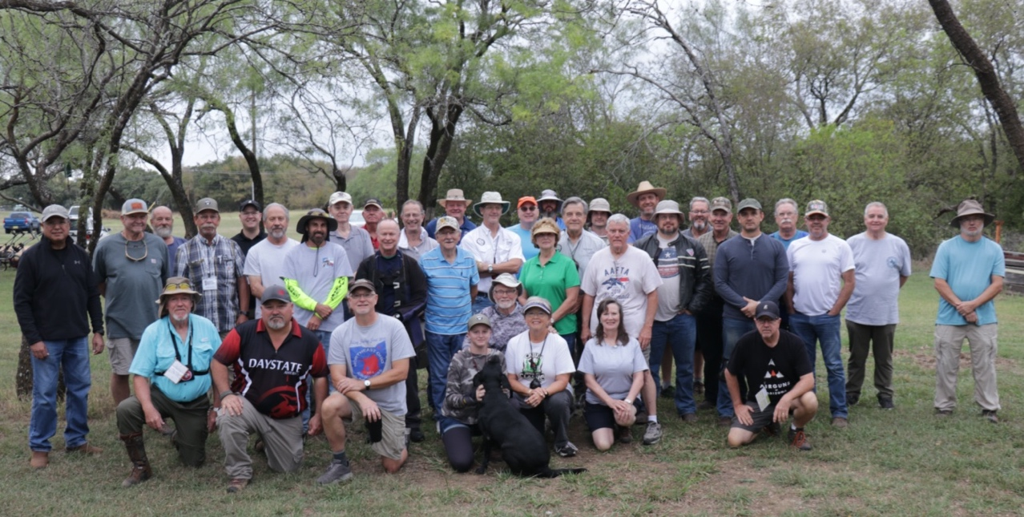
Pistol Match
13 Hunter Pistol shooters were the first to attack the lanes on Friday afternoon for the pistol match. Per AAFTA rules there were 52-shots (at least 40), the Troyer was 34.7T (minimum 30) with a SD of 6.36, and there were four offhand shots. We successfully chronographed all the pistols to insure they were under the 12 ft-lb muzzle energy limit. I’m happy to report that there were no violations. Overall, the shooters commented that they enjoyed the target placement and the lanes, but we did have one cold line for a “sticky” Turkey target. Using my target tester, I determined it was indeed “sticky”, could not be adjusted to remedy the situation and so I replaced it with one of equal size. The shooter reshot that target and knocked it down successfully. I really appreciate this new AAFTA rule for target malfunctions because it eliminates protests and ambiguity about target function and removes the impact on final scores that come from throwing out a protested target. At the end of the match, the shooters gathered under the awning to swap shooting stories, and I tallied the score sheets. There was a tie for 3rd place, so Ron Robinson and Carey Hymel had to shoot it out for 3rd. I set out a ½” KZ target at 25 yards and explained the AAFTA shoot off procedure. Ron and Carey took turns sitting and shooting the target with Carey out shooting Ron for 3rd.
The winners of the 2021 ROT Grand Prix Pistol match are:
1st Paul Bracaglia
2nd Faisal Khan
3rd Carey Hymel
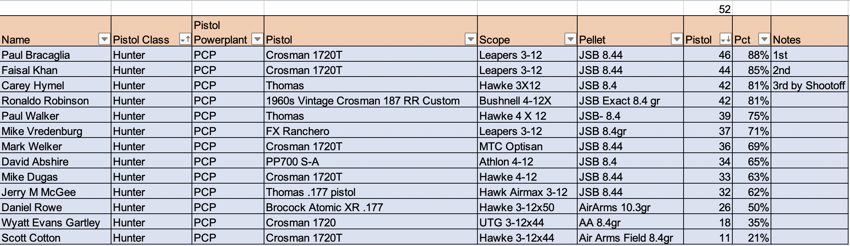
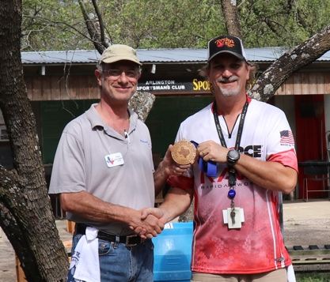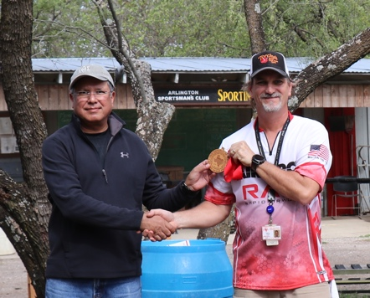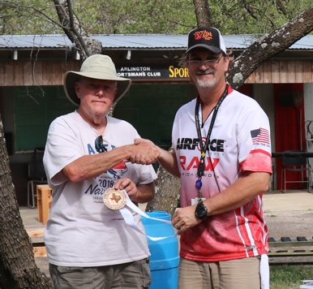
1st place Pistol 2nd place Pistol 3rd place Pistol
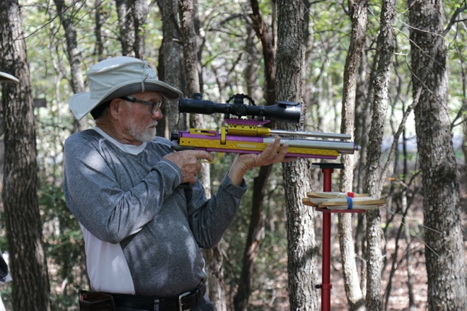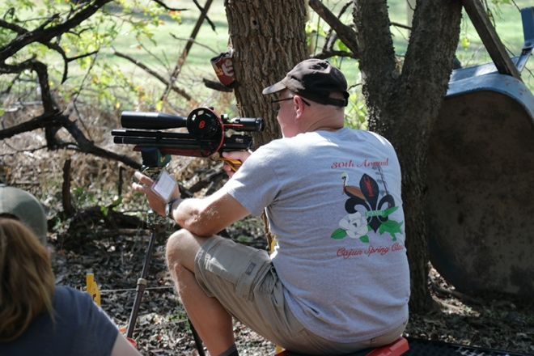
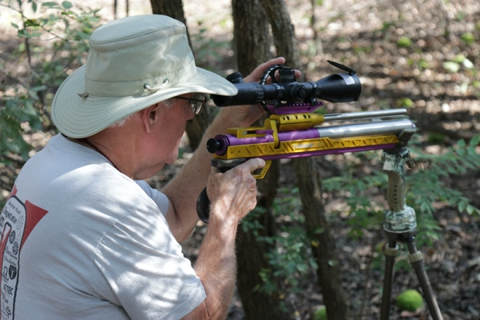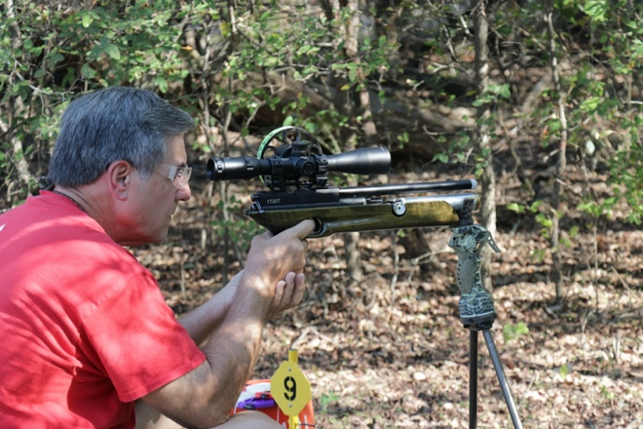
After the pistol match, Scott and I switched the course over for the rifle match on Saturday morning and I finished up other tasks and headed home about dark. Successful day #1!
Rifle Match #1
Saturday morning was cool (for Texas) and sunny with temps in the mid-60’s that climbed to the high-80’s by the afternoon. Delaying this Grand Prix into October helped with slightly more moderate weather typical for Texas in mid-Fall. Everyone had time to check in get their rifles sighted in and shoot the breeze a bit before the match started. It was my intent to chronograph all the rifles the morning of each match, but we ended up having detection issues with both chronographs on site and couldn’t complete this task. I decided to believe that shooters adhered to my threat of chronograph checking on the registration form and self-checked their rifles before arriving. I’ll investigate purchasing an AirChrony chronograph that is the official chronograph for the World and European Championship for the next ROT. Ugh…
There were 36 shooters contesting this match. We held the obligatory shooters meeting where I explained all the intricacies and procedures for the Grand Prix, and then split the shooters into 3-person squads and started shooting the first 60-shot rifle match right at 9:00am. Many thanks to Terry Hymel (from Baton Rouge) and Randy Rannberg (from OKC) who helped me each day with the administrative tasks required to run a match this big. I REALLY APPRECIATE ALL YOUR HELP.
We had a target malfunction and a target failure during this match, but using the tester and having substitute targets, the problems were rectified quickly and without drama. The Troyer rating for this morning’s course was 32.3T with an SD of 5.26. While walking amongst the shooters and taking pictures, I overheard comments about some of the targets that required shooting between trees, down from a tower, up at a target on a high pole and at a target in a dark barrel. All comments that mean I did my layout right! After about 4 hours of shooting, the shooters gathered at the awning to turn in their score cards and grab some fajitas and fixings catered by Rosa’s Café. After lunch the shooters were kind enough to gather up the targets and strings from the lanes so I could put them away and then go double check the course for Sunday with Scott. It didn’t take too long for us to finish setting it up, and then I used my target tester to perform a final test and adjustment for all the in-situ targets. I had to make a couple of adjustments which goes to show that just testing them on the bench doesn’t catch all the problems.
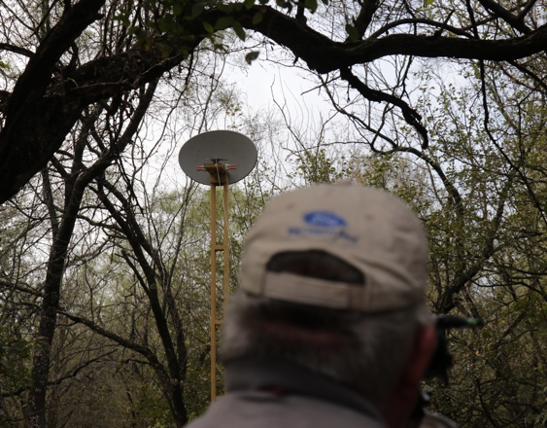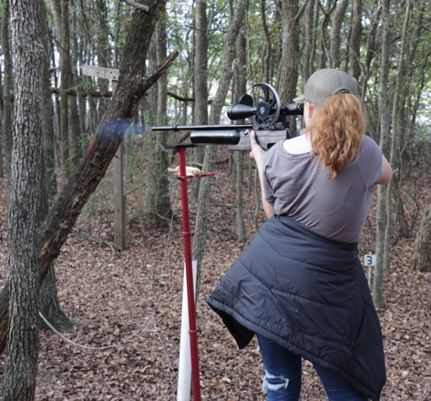
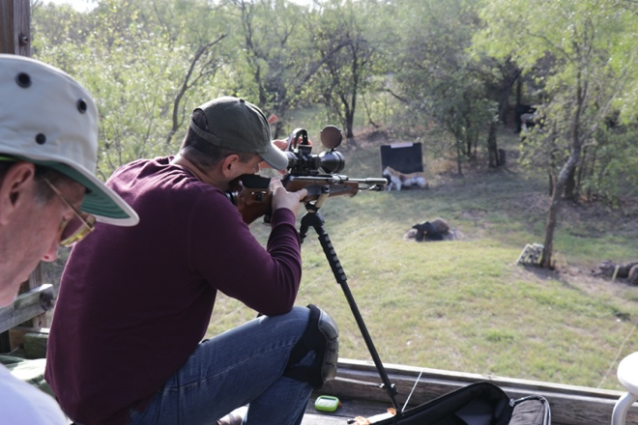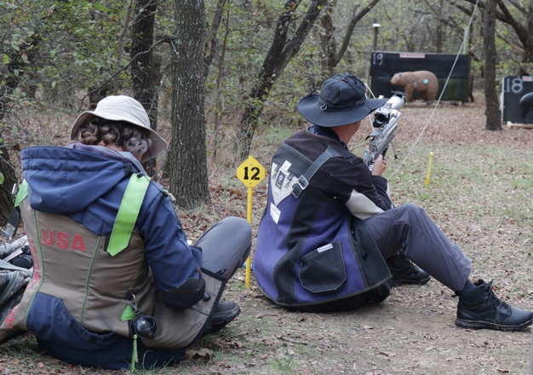
Rifle Match #2
Sunday morning was also cool (how I wished it would stay that way!!) and overcast with temps in the mid-70’s and MUCH stronger winds than Saturday. It was going to be a challenging match for shooters with swirling winds like this. After a short period to sight-in rifles, we had our shooters meeting and then got started with the 60-shot match at 9:00am. Today, I grouped the shooters by score, so that their closest competitor was shooting with them. The scores for today would add to the rifle scores from Saturday to arrive at the 120-shot match total. The Troyer rating for Sunday’s course was 31.2T with an SD of 6.59, but the high winds increased the Troyer rating and the scores from today reflected the extra difficulty.
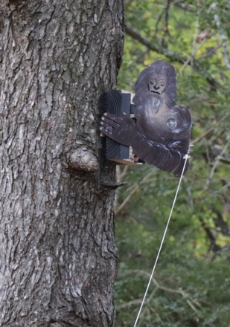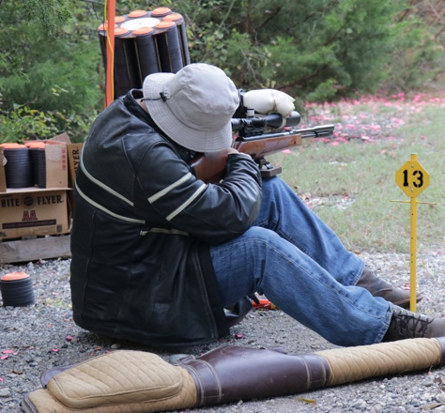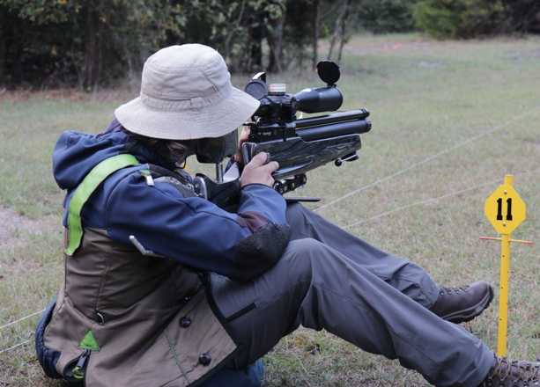
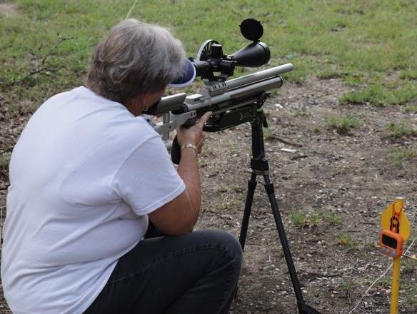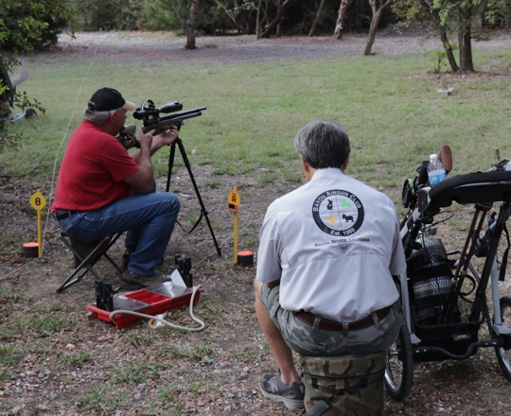
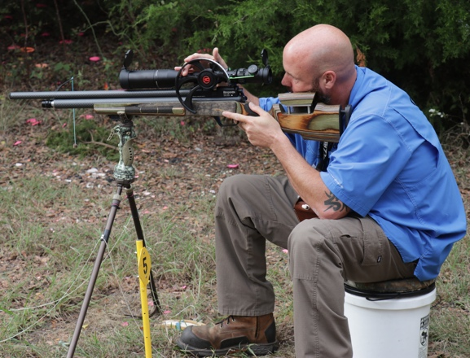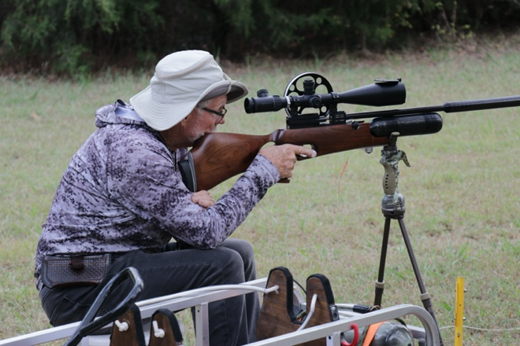
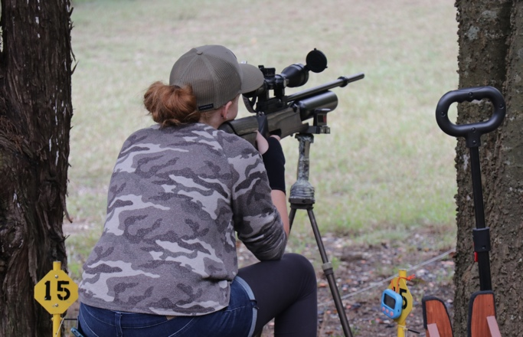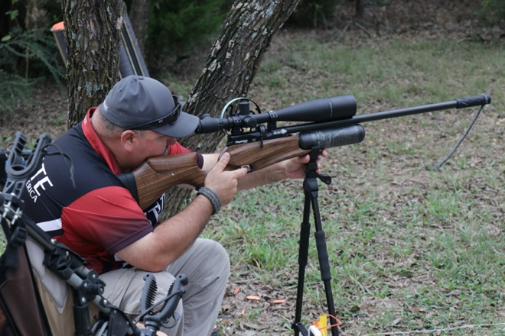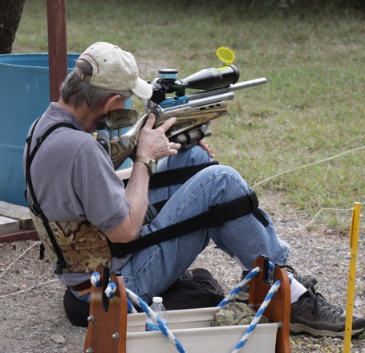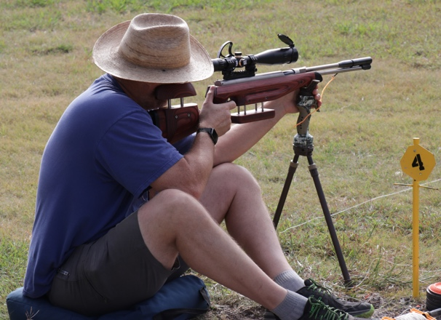
After about 3 ½ hours of shooting, the shooters gathered at the sporting clays pavilion to turn in their score cards and grab some lunch from Jason’s Deli. After tallying the scores, we needed a shootoff to determine 1st and 4th places. Once again, we set out a ½” target at 25 yards. Ron Robinson and Art Womack took turns shooting it sitting, and then kneeling and Ron came out on top for first place. Faisal Khan and Rick Cuccio took turns shooting the target sitting, and Faisal came out ahead for fourth place.
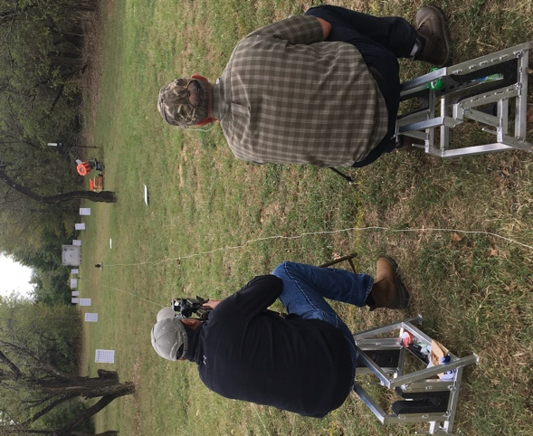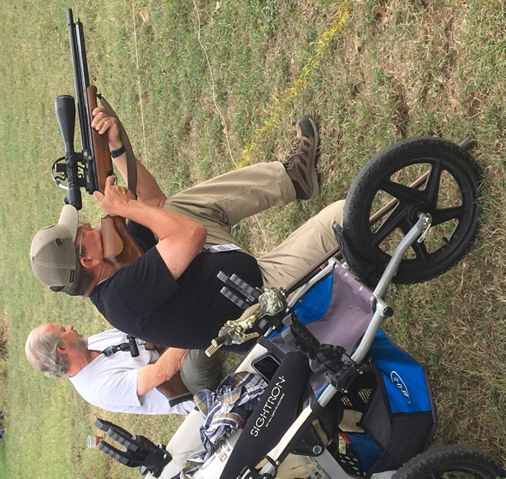
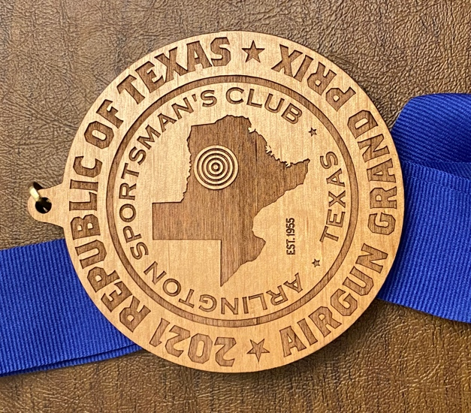
The winners of the 2021 RoT Rifle Match are as follows:
Hunter PCP – 1st Ron Robinson, 2nd Art Womack, 3rd Daniel Rowe, 4th Faisal Khan, 5th Rick Cuccio
Hunter Piston – 1st Mark Welker, 2nd Griff Crutti
Open PCP – 1st Mike Vredenburg
WFTF Piston – 1st Cliff Montgomery
WFTF PCP – 1st David Alsup, 2nd Matt Sawyer

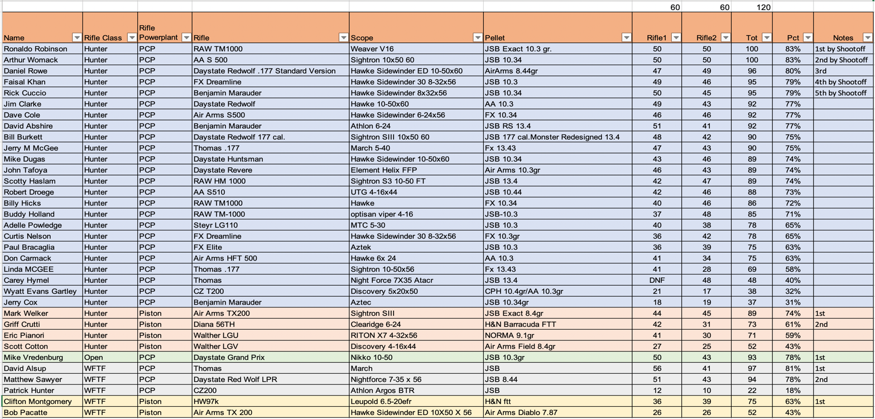
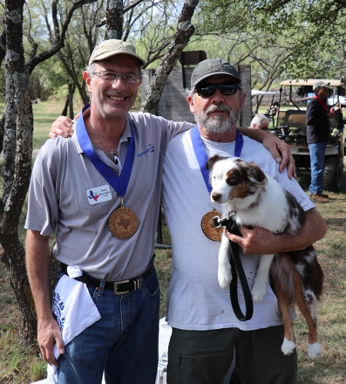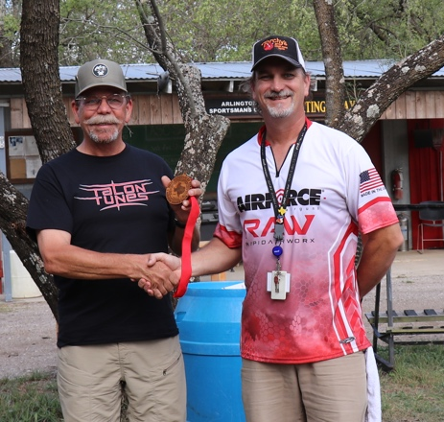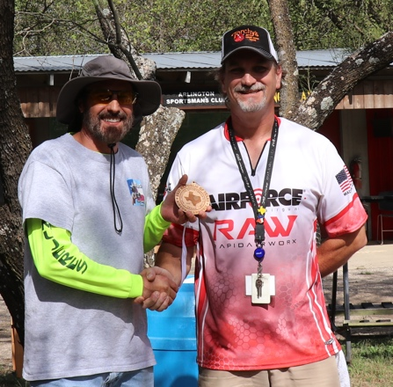
1st place Hunter PCP 2nd place Hunter PCP 3rd place Hunter PCP
(not the dog)
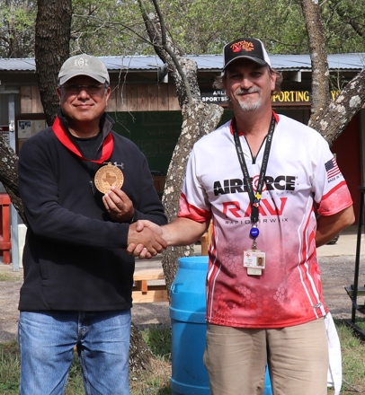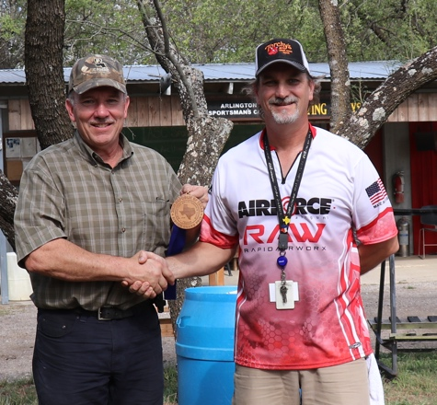
4th place Hunter PCP 5th place Hunter PCP
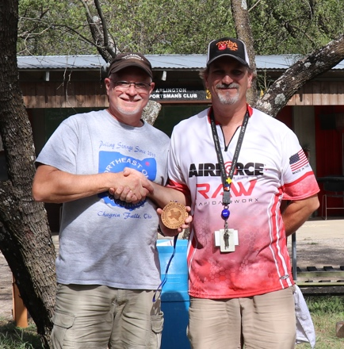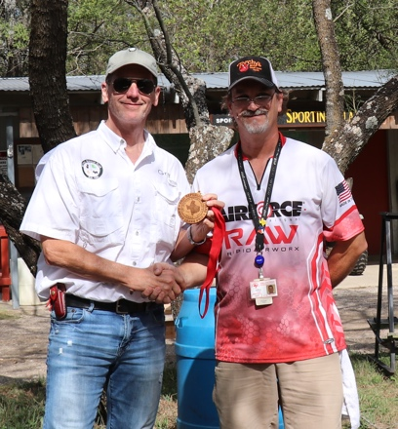
1st place Hunter Piston 2nd place Hunter Piston
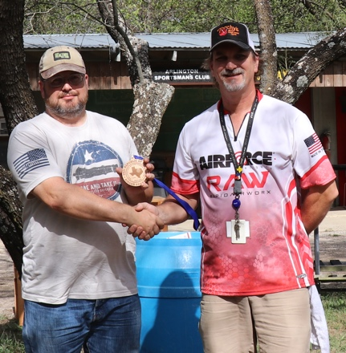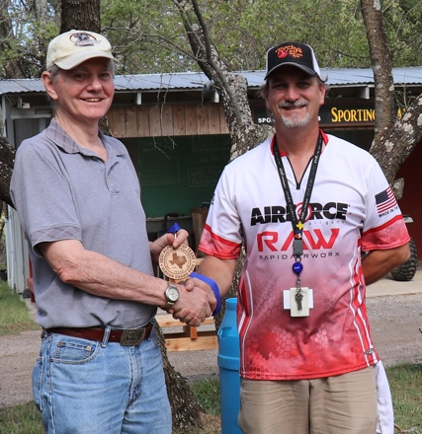
1st place WFTF Piston 1st place Open PCP
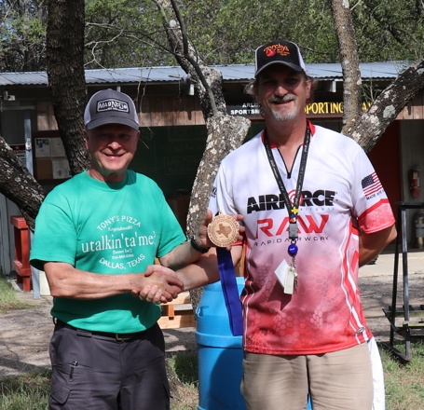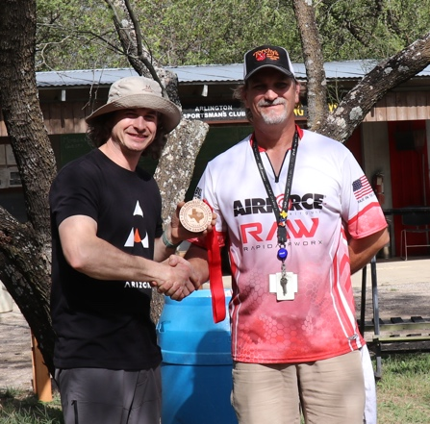
1st place WFTF PCP 2nd place WFTF PCP
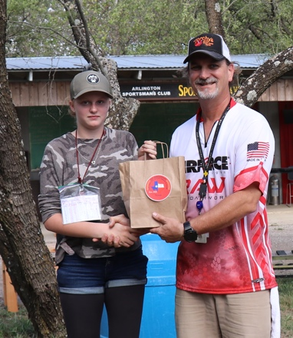
Special giveaway to Adelle Powledge our Junior Shooter
It was time for the closing activities of raffling off a Hawke Airmax scope, 3 insulated “Don’t Tread on Me” cups, and 2 lovely air rifles donated by Pyramyd Air and AirForce. Pyramyd Air donated an Air Venturi Avenger PCP rifle in .22 caliber and AirForce donated a TalonSS in a caliber of the shooter’s choice. Thank you very much Hawke, Pyramyd Air and AirForce for your generosity. Scotty Haslam won the Hawke scope, Carey Hymel won the Avenger PCP Rifle, and John Tafoya walked away with the Talon SS rifle.
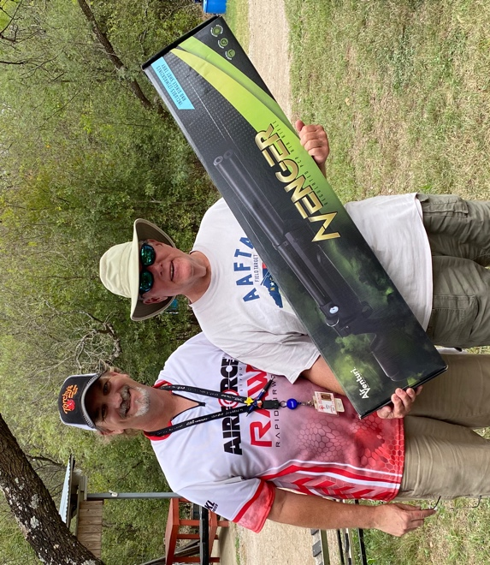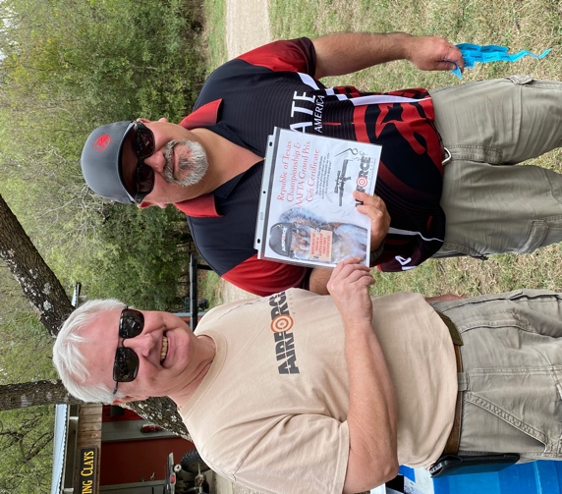

Congratulations to all the winners. To all the shooters that attended and to the volunteers, I say thank you from the bottom of my heart. It was our pleasure at ASC to put on this Grand Prix for you all; we enjoyed the company and the shooting competition.
Here is a link to Google Photos for all the pictures taken over the weekend by me and others. https://photos.app.goo.gl/U2NadMM4JjMReyZ2A
Jeff Cloud
ASC FT Match Director

