The weekend of the 16 and 17th of July was the 2nd annual Finger Lakes Field Target Grand Prix. Early in the week it was calling for rain by noon on Sunday but luckily we had two great days of shooting with only sun and some clouds.
I started about 3 weeks early this year with the preparation for the shoot. I got all the targets together that I needed and thankfully had enough for both courses and the pistol shoot. I started fixing all the broken ones and went on to grinding all the paint off every target down to the bare metal. Then repainted all of them fresh like new. OK, one less thing to worry about.
The week before the shoot I had put out the call that I needed some help mowing the lanes and thankfully Paul Manketlow and Doug Rogers answered. Mark Deboard said he would be there to help but it wouldn’t be until after he was done with work. Paul and Doug really tackled the mowing while I was putting bricks in the ground on the zeroing range and getting targets ready. By the time I got down to help with the mowing they were almost done so I got out the weed wacker and knocked back all the weeds that may have leaned onto the shooting lanes. (MANY THANKS TO THOSE TWO!)
On the prior Thursday, Doug and I went down to the woods course and set up all the targets and pulled the strings out. We were both pretty whipped but we also laid out the field course so we knew it was done and ready. On Friday I went to the range and made sure every target could be seen and nothing was in the way of each kill zone as well as set up the pistol course. I did a little refining on the field course and made sure everything was ready for Saturday. While I was on the field course Leo and Chas showed up and set out the sight in range for me.
Saturday… I was there at 6:15am to get water and ice in the cooler and set up the paperwork, raffle prizes ect. I was expecting I would have quite a few people show up right at 7:30am when I opened the sight in range but shooters trickled in slowly. I had made the shooters meeting to be at 9:45am so everyone had time to zero their guns. Maybe that’s why there wasn’t any rush but that turned out to be a good thing. I was so busy at the registration table over the two plus hours I didn’t even have time to zero my own gun but I got everyone registered, gave them their shirts, handed out tickets for the raffle and gave everyone a $5.00 ticket towards lunch there at the range. Once again Doug stepped up and helped out doing the chronograph testing for me. At 10am (15 minutes late) I had the shooters meeting and had everyone go down to the woods course. I called hot line about 10:20am. The shoot was off and running. Through the course we only had one cold line for a target that got caught up. I received many compliments for the course and only one complaint that was raised. There was one target that someone had to take a kneeling shot at. I had made sure every target could be seen from the legal height from between the lane markers. This shooter was a shorter shooter who unfortunately couldn’t see the kill zone when he was sitting. I will remember him when I place targets next year. I only had two targets per lane so things moved along quickly and we were done around 1pm. The previous year Pat Shirhall and Janet Manketlow helped me with the scoring and score board so I asked if they would help me again and thankfully they were nice enough to say yes. While I was collecting the extra targets and setting the pistol targets they were collecting the cards and totaling them. This certainly helped me out!!! I made my way up to the shed to put targets away and then went to get something to eat.
The pistol match was set for 3pm shooters meeting and that’s when I started. Luckley we had enough shooters to make the minimum because two shooters dropped out and one thankfully joined. So about 3:10pm we started. I made the pistol course hard and I also made it 60 shots. When shooters found out it was 60 shots I got an ear full of groans! No cold lines through the pistol shoot and shooters jumped right in to help clean up. Then a few more groans about how long it was. Next year 40 shot pistol course! I heard all of you loud and clear. I was quite exhausted at the end of the pistol course as I am sure everyone else was as well. Especially after having the rifle shoot the same morning. I have made the rifle and pistol both on Saturday so that shooters don’t have to take a Friday off work and they don’t need to have the extra charge of another hotel night to pay for. So far it has worked out as far as I know. By 5:45pm everyone was gone and I headed home for a good night’s sleep.
Sunday… I was again at the course early to get things set for the day. Shooters trickled in and got their guns set at the sight in range and I even had 5 minutes to through some pellets down range to confirm my zero while Doug did the chronograph testing again for me. Safety meeting was at 8:45am and we were on the lanes at 9am ready to shoot. I called hot line and had to go cold right away for a target that wouldn’t come up. It was fixed by one of the other Marshals so we were all set. I called hot line and was told about another problem on the same lane as the previous cold lane so I had to go cold again. Apparently a deer must have gotten caught on one of the lines on lane six and pulled the string all the way over across lane one right in front of the kill zone on a target. Things were fairly smooth for a while until I had to go cold for a target malfunction. Greg Shirhall said he needed a replacement target so I went and got one and he replaced the target. When he came back and gave me the target, I could see that the pin and the push nut that holds the paddle in place had fallen out. It fell off right there at the target so at least I knew I put a functioning target out there. One more cold line later for a caught string and that was it. I hate having cold lines because it breaks the shooters concentration and makes the game longer.
I got some very nice complements about both rifle courses being set up well. I am really glad that people liked them. I also want to hear when there are issues, that way I can try to fix them the following shoots so that everyone can have a good time.
On to the raffle and the awards. This year I was helped out from Airguns of Arizona, Sightron, Crosman, Hard Air Magazine Pyarmid Air and UTG. People went away with some really nice prizes from the raffle ticket drawing.
One of the things that I like to do is find the shooter with the lowest score. This is not to single them out but to help them out. Hard Air Magazine donated to me a few Beeman PCP’s. At other shoots, I’ve seen some really good shooters get the top guns as prizes. I think that’s great for them, but I also see the newer shooters trying to get better and think how much one of these top guns could help. I want everyone to enjoy this sport as much as I do, so for the past two years I have given the shooter with the lowest score the donated Beeman PCP. This year a younger shooter from my own club was awarded this gun and I hope he enjoys it.

The Troyer was 32.49 for day 1 in the woods.
The Troyer was 34.30 for the pistol course.
The Troyer was 33.59 for day 2 in the field.
Here is the way things stacked up:
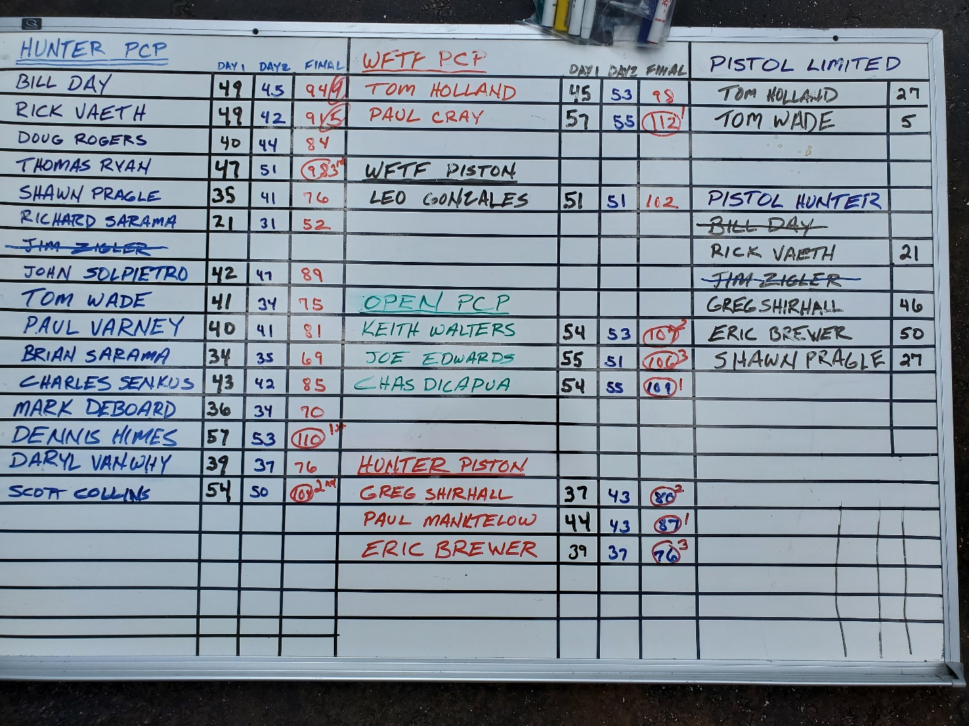
A big thanks for all the shooters that came out to enjoy a weekend of fun!!!

